Name：Eric | Gender：male | 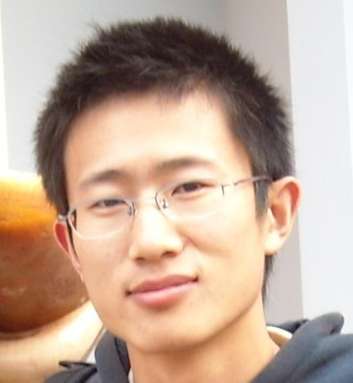
Birthday：1985-05-16 | Hometown：Dalian
Residence： Dalian
Tel：8617722667822
email:cat555666@126.com
Experience ：11 years
Notice Period in current Organization: 1 months

Summary
More than 11 Years of experience in Web Application Development & Designing.
Proficiency in Java, J2EE and the frameworks like Thread, Spring, myBatis, Oracle, MySQL.
Extensive experience in developing various web based applications using myBatis and Spring frameworks.
Experience with WEB 2.0 technologies like JavaScript, Ajax and CSS, HTML.
Strong interpersonal and communication skills with an ability to lead a team and keep them motivated.
Skills and Awards:
- Java: Ant, Maven, Apache Struts, Apache Tomcat, CXF, Eclipse IDE, Hibernate, myBatis, IBM WebSphere Application Server, IBM WebSphere Commerce, JAX-RS, JSTL, Java EE, Java SE, Java Server Pages (JSP), Java Servlets, Spring Framework, Spring MVC, Spring boot, Spring cloud;
- Software Construction: Ext JS, JQuery;
- Software Engineering Management: Agile Lifecycle Management.
- Middleware: Zookeeper, Kafka, Nginx
- Other: Linux shell/command, network theory, high concurrent distributed system design.

Achievement
- 2016.7 Design and coding javascript “js OOP” framework. Please refer to https://github.com/tiger3615/OOPJSByPrototype
- 2018.2 Got IELTS with 5.0
- 2018.5 Design and coding “distributed Biz monitor Tool”
- 2018.6 Design and coding “Distributed File search” Tool. Refer to https://github.com/tiger3615/DistributedFileSearch/wiki
- 2018.9 Design and coding “distributed thread synchronizer” framework. Please refer to https://github.com/tiger3615/distributedConcurrent/wiki
- 2019.1 Design and coding “Quantity and Index” tool. It is handy for distributed applications to fetch data and never duplicated fetch. Refer to https://github.com/tiger3615/QuantityAndIndex/wiki/Introduce

Work Experience
Jan-2018 - now - Senior Software Engineer, SF co.,ltd, http://www.sf-express.com
Project: ADES(Agent Data Exchange System), DC(Data Collection)
Project Role: key developer & Technical Leader
Tasks performed: Worked both in ADES DC project.
Involved in designing DB.
Involved in designing high performance Data Collection system.
Involved in developing multi-thread control code, include dynamically add or kill thread.
Involved in project management.

Jul-2015 - Sep-2017 - Senior Software Engineer, EPAM Systems, http://www.epam.com
Customer: UBS
Project: UBSJ-WMSD, EOL UBS (Wealth Management)
Project Role: key developer
Tasks performed: Worked in EOL UBS wealth management project.
Involved in developing features according to business requirements.
Involved in migrating all ICAWB application components into Production.
Provided extended support to fix issues during migration of ICAWB applications.
Unit testing and integration testing using TDD

Jul-2014 - Jun-2015 - Citi Bank DL DC
Customer: CitiBank Japan
Project: The compliance website provide report and deal pre-clearance.
Project Role: Senior developer
Tasks performed: Interacting with the client to understand the project and finalize its scope.
Estimation, design and development of various modules.
Bug fixing and maintenance of the product.
Mentoring junior members in the team.
Coordinating with other teams working on the same project.
Ensuring smooth delivery of the project.

Apr-2010 - Jul-2014 - SSE, Fidelity
Customer: Fidelity HongKong
Project: Fund trade website used to trade retail and retirement fund.
Project Role: Senior developer
Tasks performed: Development of Java interfaces & Configuration Management of the source code.
Working with users to establish requirements and determine priorities.
Developing new applications, components & functionality to existing systems.
Involved in accurately providing estimated development times.
Developing new features, both back-end and front-end.
Analyzing data and conducting compatibility
Investigating alternate configurations & implementing better solutions.
Jul-2008 - Set-2009 - SE, Neusoft(Dalian)
Customer: SARFT(The State Administration of Radio and Television)
Project: The software for monitoring Cable Television content.
Project Role: Developer
Tasks performed: Development of frontend UI includes Report and Media Player.

Education
Graduation Year: 2008
Name of the Education Establishment: Shenyang University of Technology
Faculty/College: Software Academe
Degree (diploma): Bachelor

